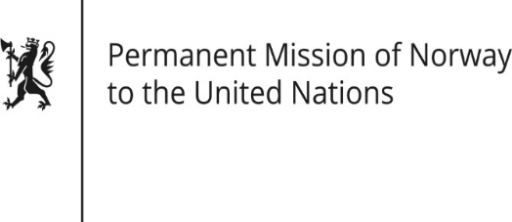

STATEMENT
38th UPR session of the Human Rights Council
on the human rights situation in Mozambique
as delivered by Ambassador Tine Mørch Smith,
Permanent Representative of Norway

4 May 2021

Check against delivery
Madame President,

Norway recommends that Mozambique:
First; ensures humanitarian access to affected communities in conflict zones, and investigates human rights violations and abuses and holds those responsible to account;

Second; consolidates all electoral laws and regulations into one integrated electoral legal framework, and establishes a permanent and reliable voter registration system;

Third; ensures that on-going revisions and reforms of media laws protect freedom of expression and media freedom, promote media pluralism, and are based on stakeholder consultations;

Fourth; protects children’s rights of access to health and education, and puts in place measures to prevent all kinds of violence against children;

Fifth; implements a national action plan on discrimination against persons with albinism, with concrete indicators and a timeline with regard to ensuring access to health, education, employment and social integration.

Thank you.

