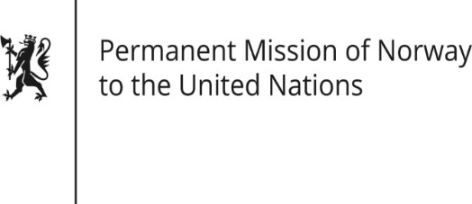

STATEMENT
38th UPR session of the Human Rights Council
on the human rights situation in Denmark
as delivered by Ambassador Tine Mørch Smith,
Permanent Representative of Norway

6 May 2021

Check against delivery
Madame President,

Norway commends Denmark for its persistent efforts to safeguard human rights and fundamental freedoms worldwide, for an open and inclusive UPR process, and for progress made since its last UPR.

Norway recommends that Denmark:

- abolishes the use of solitary confinement on minors and ensures that its use as a disciplinary measure for inmates is in accordance with the Mandela Rules, as recommended by the Council of Europe's Committee for the Prevention of Torture and Inhuman or Degrading Treatment or Punishment;

- continues efforts to combat hate crime, specifically following up on ECRI’s recommendations to establish a comprehensive data collection system that would facilitate more efficient policy design and better analysis of the hate crimes committed;

3. continues efforts to combat violence against women, including increasing the attention paid to female victims of gender-based violence in policy documents and ensuring funding as recommended by GREVIO.

Thank you.

