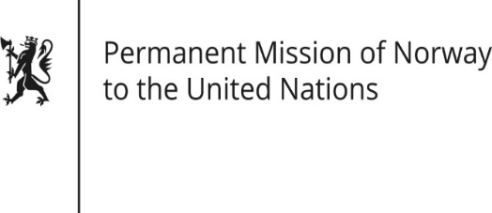

STATEMENT
38th UPR session of the Human Rights Council
on the human rights situation in Belgium
as delivered by Ms Jannicke GRAATRUD,
Minister, Deputy Permanent Representative

5 May 2021

Check against delivery
Madame President,
Norway welcomes Belgium’s participation in the UPR and notes the positive steps taken since its last review,

Norway recommends that Belgium:

1. strengthens efforts to combat violence against women and domestic violence, including by ensuring adequate funding and increased coordination between state and federal actors and civil society;
2. ratifies the Optional Protocol to the Convention against Torture and establishes a preventive mechanism in accordance with the Optional Protocol;
3. establishes mechanisms guaranteeing the human rights of prisoners and detainees at all times, as highlighted by the Council of Europe’s Committee for the Prevention of Torture and Inhuman or Degrading Treatment or Punishment (CPT).

Thank you.

