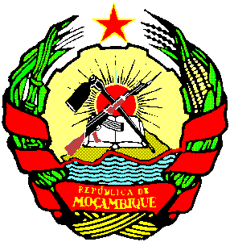
REPUBLIC OF MOZAMBIQUE

STATEMENT BY THE MINISTRY OF JUSTICE, CONSTITUTIONAL AND RELIGIOUS AFFAIRS OF MOZAMBIQUE

38 SESSION OF THE UPR WORKIMG GROUP

7 May 2021

Madam President,

Distinguished Members of the UPR Working Group

Distinguished Members of the Troika

Ladies and Gentlemen,

On behalf of the Government of the Republic of Mozambique it is with great honor, once again, to reaffirm our commitment to respect, promotion and protection of the Human Rights.

We take this opportunity, to commend you Madam President and all members of the Bureau of the Human Rights Council, for the excellent manner you are conducting the proceedings of this session.

The Universal Periodic Review Mechanism based on the principle of sovereign equality of States, is for us, an important tool, that helps us to assess and reflects open and constructively on the situation of the human rights in the world.

We would like to express our deepest thanks to all member States that participated in this session, in particular to the 106 States that made valuable recommendations, which will contribute greatly to the improvement of Human Rights in Mozambique, thereby guaranteeing the well-being of all citizens.

Madam President,

We would like to commend and thank for the excellent facilitation work carried out by the Troika formed by Armenia, Eritrea and the Philippines and by the Secretariat, which for two days worked intensively with our team in the preliminary assessment process of the 269 recommendations formulated in the course of the interactive dialogue.

At the end of these two days of work with the troika, we received the recommendations compiled in thematic areas, a methodology that facilitated and will continue to facilitate the identification of the relevant sectors in the process of implementing them.

Madam President,

The interactive dialogue was open and constructive. Delegations expressed their comments and their points of views on the situation in Mozambique, recommending to take measures to ensure the full enjoyment of Human Rights by all in Mozambique.

We thank the sympathy and solidarity expressed by several delegations in regard of the humanitarian crisis in the Cabo Delgado Province, victim of acts of terrorism, and for the negative impacts of the natural disasters.

Assuming the relevance and complexity of the process and the need to ensure that it is participatory and inclusive, involving all key actors, we intend to refer the recommendations to a deeper consultation, which allows us to take a more rational position.

In this context, we intend to establish greater transparency and publicity in the process of consulting the recommendations, which is why we will only be able to announce our final position, before the session of the Human Rights Council that will adopt the Final Report on the III cycle Mozambique review, to be held in September 2021.

Finally, we want to reiterate our country's commitment to the universal periodic review mechanism, to the Human Rights Council and to the cause of human rights in general.

Thank you very much for your attention!

