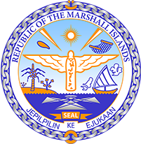
Republic of the Marshall Islands
STATEMENT by H.E. Doreen de Brum
37th session, Universal Periodic Review
27 January 2021
Geneva
Sao Tome and Principe

Check against delivery

Thank you, Madam President.

The Republic of the Marshall Islands warmly welcomes the delegation of Sao Tome and Principe and thanks them for their report.

We commend the efforts of Sao Tome and Principe in ratifying a number of core Human Rights treaties, including the ICCPR, CERD and CAT, as well as the Optional Protocol of the CEDAW.

We are pleased to note the creation of the Climate Change Adaptation Project and the West African Coastal Resilience Investment Project, both aimed at mitigating the effects of climate change.

We offer the following recommendations for Sao Tome and Principe’s consideration:

- Develop a comprehensive strategy addressing the sustainable use, management and conservation of marine ecosystems and associated resources.
- Take measures to prevent flooding and erosions, such as planting trees and building flood detention basins.
- Take further action to achieve gender equality, such as establishing a plan to increase female participation in political institutions, as well as preventing sexual violence against women and girls.

In closing, we wish the delegation of Sao Tome and Principe a very successful review during this third UPR cycle.

Kommol tata and thank you.

