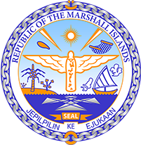

Republic of the Marshall Islands
STATEMENT by Mr. Samuel K. Jr. Lanwi, Deputy Permanent Representative
37th Session, Universal Periodic Review
20 January 2021
Geneva
Saint Lucia

Thank you, Madam President.

The Republic of the Marshall Islands warmly welcomes the delegation of Saint Lucia and thanks them for their report.

We commend Saint Lucia on its initiatives to protect women and girls, most notably on its National Plan of Action to end gender-based violence.

Likewise, we welcome Saint Lucia’s efforts to mitigate the effects of climate change, particularly through the establishment of a National Adaptation Plan, as well as sectoral adaptation plans.

We offer the following recommendations for Saint Lucia’s consideration:

1. Develop and implement legislation that prohibits child marriage.
2. Increase efforts to fully eliminate child labor, especially the worst forms of child labor.
3. Increase the number of prosecutions of cases of gender-based violence, as well as the legal and psychological assistance provided to its victims.

In closing, we wish the delegation of Saint Lucia a very successful review during this third UPR cycle.

Kommol tata and thank you.

