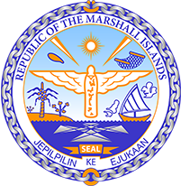

Republic of the Marshall Islands
STATEMENT by Mr. Samuel K. Jr. Lanwi
37th Session, Universal Periodic Review
19 January 2021
Geneva
Saint Kitts and Nevis

Check against delivery

Thank you, Madam President.

The Republic of the Marshall Islands warmly welcomes the delegation of Saint Kitts and Nevis and thanks them for their report.

We welcome Saint Kitts and Nevis’ ratification of the Convention on the Rights of Persons with Disabilities and its efforts to improve the lives of disabled persons. We especially commend its initiatives aimed at improving accessibility in public infrastructure.

Likewise, we are pleased to note that the government has taken critical steps in building resilience and mitigating the impacts of climate change on the human rights of its population, through its Climate Change Adaptation Strategy.

We offer the following recommendations for Saint Kitts and Nevis’ consideration:

- Establish a strategy to combat gang violence and specifically keeping children in school and preventing them from joining gangs.
- Increase the number of women in decision making roles, especially in public and political life.
- Develop and adopt legislation that prohibits discrimination against persons living with disabilities.

In closing, we wish the delegation of Saint Kitts and Nevis a very successful review during this third UPR cycle.

Kommol tata and thank you.

