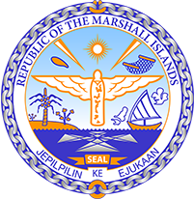

Republic of the Marshall Islands
STATEMENT by Mr. Samuel K. Jr. Lanwi, Deputy Permanent Representative
37th Session, Universal Periodic Review
21 January 2021
Geneva
Nepal

Check against delivery

Thank you, Madam President.

The Republic of the Marshall Islands welcomes the delegation of Nepal and thanks them for their report.

We welcome Nepal’s Ten-Year National Master Plan against Child Labor, which aims at eliminating child labor by 2025.

Nevertheless, we remain concerned about the lack of protection of indigenous people and the violation of their human right to use their land and natural resources freely. Recent hydropower generation projects have threatened their lands, waters and natural resources. Those development projects have been undertaken without informing the communities concerned beforehand.

We offer the following recommendations for Nepal’s consideration:

1. Ensure that existing legislation prohibiting child labor is fully implemented and its enforcement monitored.
2. Ensure that the rights of indigenous communities regarding the use of their land are upheld, through the revision of the legislation on this matter.

In closing, we wish the delegation of Nepal a very successful review during this UPR cycle.

Kommol tata and thank you.

