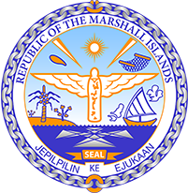

Republic of the Marshall Islands
STATEMENT by H.E. Doreen de Brum, Ambassador & Permanent Representative
37th Session, Universal Periodic Review
27 January 2021
Geneva
Interactive Dialogue: NAURU
Check against delivery

Thank you, Madam/Mr. (Vice) President.

The Republic of the Marshall Islands warmly welcomes the delegation of Nauru to this UPR cycle and thanks them for their report.

We commend Nauru for its efforts to implement the Convention on the Elimination of all forms of Discrimination Against Women, as well as the Convention on the Rights of the Child into domestic law. We especially welcome Nauru’s adoption of the Domestic Violence and Family Protection Act in 2017, which aims at providing protection and assistance to victims of domestic violence.

We are very pleased to note the Government’s development of its Climate Change Strategic Plan for Adaptation and Mitigation, which focuses on developing climate change policies involving key stakeholders, as well as building resilience. Nevertheless, we remain concerned about the threat to access to drinking water due to saltwater intrusion resulting from climate change.

We offer the following recommendations for Nauru’s consideration:
- Develop and implement legislation and policies to achieve gender equality and to prevent gender-based violence, including domestic violence against women.
- Provide women with benefits required under CEDAW.
- Develop and implement a project to ensure sustainable access to drinking water for the entire population.

In closing, we wish the delegation of Nauru a very successful review during this third UPR cycle.

Kommol tata and thank you.

