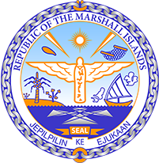
Republic of the Marshall Islands
STATEMENT by H.E. Doreen de Brum
UPR 37th session
25 January 2021
Geneva

Myanmar

Check against delivery

Thank you, Madam President.

The Marshall Islands welcome the delegation of Myanmar and thanks it for its report.

After years of engagement on human rights with Myanmar, it is high time that the recommendations by the Advisory Commission on Rakhine State be implemented and we encourage the newly-elected government to do so.
We offer the following recommendations:

- Eliminate statelessness and institutionalized discrimination against minorities by repealing the 1982 citizenship law.
- Ensure compliance with the provisional measures order of the ICJ, and cooperate fully with international justice and accountability mechanisms.
- Take concrete action to hold the military to account for the systematic use of sexual and gender-based violence.

Kommol tata and thank you.

