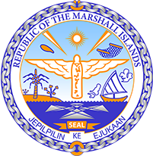

Republic of the Marshall Islands
STATEMENT by Samuel K. Jr. Lanwi, Deputy Permanent Representative
37th Session, Universal Periodic Review
19 January 2021
Geneva

Interactive Dialogue: MAURITANIA

Check against delivery

Thank you, Madam President.

The Marshall Islands welcomes the Delegation of Mauritania to the third cycle of the UPR and thanks them for their report.

We welcome Mauritania’s launching of its National Adaptation Plan process. This is a positive step for Mauritania as it will help to prevent and mitigate the effects of climate change, particularly drought, decreasing rainfall and flash floods.

While we also welcome the establishment of the National Monitoring Commission on Women and Girls’ Rights, we remain concerned about continued reports on the lack of prosecution of gender-based violence and the persistence of female genital mutilation in some regions and among some ethnic groups.

We offer the following recommendations for Mauritania’s consideration:

- Amend the Constitution to abolish the death penalty.
- Define rape as a criminal offence in consistence with international human rights standards and ensure that cases of violence against women and girls are adequately investigated, prosecuted, and punished.

Kommol tata and thank you.

