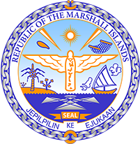
Republic of the Marshall Islands
STATEMENT by H.E. Doreen de Brum
UPR 37th session
26 January 2021
Geneva
Georgia

Check against delivery

Thank you, Madam President.

The Marshall Islands welcomes the delegation of Georgia and thanks them for their report.

We welcome the efforts by Georgia with regard to gender equality, including the 2018 amendment to its Constitution.

We further commend Georgia’s measures to safeguard the right to live in a safe and healthy environment. While we fully endorse self-reliance on green energy, the harmful effects of the planned hydropower projects to the ecosystem and humans living in the area must not be overlooked.

We offer the following recommendations for Georgia’s consideration:

- Consider shifting resources from hydropower to more sustainable solutions such as solar power.
- Step up efforts to combat all forms of violence against women, including through public awareness campaigns and protection mechanisms.
- Develop a strategy to protect children living and working on the streets and increase investigations and prosecution for trafficking in children.

Kommol tata and thank you.

