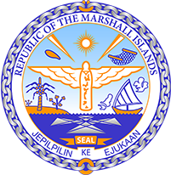

Republic of the Marshall Islands
STATEMENT by Mr. Samuel K. Jr. Lanwi
36th Session, Universal Periodic Review
22 January 2021
Geneva
Austria

Check against delivery

Thank you, Madam President.

The Marshall Islands welcome the Delegation of Austria and thanks it for its report.

We congratulate Austria on withdrawing its reservations to CEDAW and CRC.

The Marshall Islands recognizes Austria’s continued efforts in eliminating all forms of discrimination and violence against women and girls, and wish to offer the following recommendations for Austria’s consideration:

- Amend the legal definition of rape in the criminal code to be based on lack of consent. Additionally, provide support and assistance to victims of rape, including bringing the rate of prosecutions and convictions of rape and sexual violence in conformity with the rise in reporting of such cases.
- Adopt a comprehensive strategy to eliminate discriminatory stereotypes of women and their portrayal as sexual objects. And Ensure that children are educated about responsible sexual behaviour.

We wish Austria a successful review.

Kommol tata and thank you.

