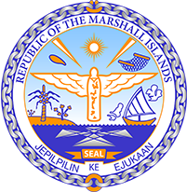

Republic of the Marshall Islands
STATEMENT by H.E. Doreen de Brum, Ambassador & Permanent Representative
37th Session, Universal Periodic Review
20 January 2021
Geneva

Interactive Dialogue: AUSTRALIA

Check against delivery
Thank you, Madam President

The Marshall Islands welcome the Delegation of Australia to this UPR cycle and thank them for their report.

We commend Australia for the withdrawal of its reservation to CEDAW relating to women in combat roles.

We remain very concerned about Australia’s insufficient progress in lowering their greenhouse gas emissions. The production and use of fossil fuels continue to play a significant role in climatic events such as wildfires and droughts. In this regard, we strongly urge the Government to reconsider its stance on this issue.

We offer the following recommendations for consideration.

- Work consistently towards its target in conformity with the Paris Agreement to keep global warming below 1.5 degrees Celsius, by phasing out the use of coal.
- Take targeted action to protect indigenous women and children from family, domestic, and sexual violence by increasing options for support.

Kommol tata and thank you.

