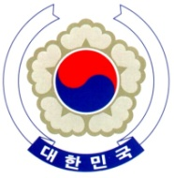

PERMANENT MISSION OF THE REPUBLIC OF KOREA
GENEVA

The 37th Session of the UPR Working Group <Check against delivery>
Review of Rwanda
Geneva, 25 January 2021

Statement of the Republic of Korea

Thank you, Madam President.

The Republic of Korea commends Rwanda’s efforts to strengthen its institutional capacity to protect human rights, including the adoption of the first-ever National Human Rights Action Plan. We also acknowledge Rwanda’s achievements in mainstreaming gender equality and enhancing women’s representation in the private and public sectors.

Bearing this in mind, we would like to recommend Rwanda to:

- Continue its efforts to improve conditions in detention facilities including the overcrowding issue;

- Continue its efforts to strengthen the legal framework to combat gender-based violence against women, including domestic and sexual violence; and

- Continue implementing reforms aimed at expanding media freedoms and creating a citizen-centred media to ensure all individuals fully enjoy the right to freedom of expression.

We wish Rwanda a successful review. I thank you.

/END/

