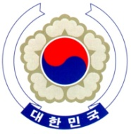

PERMANENT MISSION OF THE REPUBLIC OF KOREA
GENEVA

The 37th Session of the UPR Working Group <Check against delivery>
Review of Lebanon
Geneva, 18 January 2021

Statement of the Republic of Korea

Thank you, Mr. President.

The Republic of Korea warmly welcomes the delegation of Lebanon.

We acknowledge the continued efforts made by Lebanon to protect and promote human rights. In particular, we welcome the advances made in its national legislation for the establishment of the National Human Rights Commission and the Committee for the Prevention of Torture.

With such progress in mind, we would like to present the following recommendations to Lebanon.

- Step up its efforts to fully operationalize the National Human Rights Institution and the Committee for the Prevention of Torture to combat impunity and ensure appropriate judicial procedures;
- Make further legislative efforts to prevent domestic violence and lift its reservation to the Convention on the Elimination of All Forms of Discrimination against Women (CEDAW); and
- Take necessary steps to ensure the safety of journalists and peaceful protesters as a way to guarantee freedom of expression and assembly.
We wish Lebanon a successful review. I thank you.
/END/

