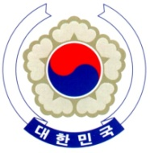

PERMANENT MISSION OF THE REPUBLIC OF KOREA
GENEVA

The 37th Session of the UPR Working Group <Check against delivery>
Review of Georgia
Geneva, 26 January 2021

Statement of the Republic of Korea

Thank you, Madam President.

The Republic of Korea welcomes Georgia’s comprehensive efforts to implement the recommendations of is last review. We appreciate Georgia’s Constitutional amendments to realize gender equality as well as its National Action Plan to combat violence against women and protect the victims and survivors. Also, we take note of its efforts to protect the rights of internally displaced persons (IDPs) by continuously updating its State Strategy and Action Plan.

In a constructive spirit, we would like to recommend the following:

- Make further efforts to improve the quality of education and eradicate discrimination in school;
- Step up its efforts to prevent gender-based violence including domestic violence, in particular, to ensure that relevant laws and practices comply with international human rights standard; and
- Continue taking the necessary measures to address concerns over the rights of vulnerable groups, including IDPs, refugees, migrants, and persons with disabilities for their social cohesion.

We wish Georgia a successful review. I thank you.

/END/

