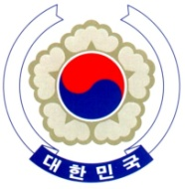

PERMANENT MISSION OF THE REPUBLIC OF KOREA
GENEVA

The 37th Session of the UPR Working Group <Check against delivery>
Review of Austria
Geneva, 22 January 2021

Statement of the Republic of Korea

Thank you, Madam President.

The Republic of Korea warmly welcomes Austria to its third cycle of the UPR.

We welcome the progress made since its last review, including the legal and institutional developments concerning the rights of women, persons with disabilities, and children. We also appreciate Austria’s continued efforts to combat hate crimes and hate speech on the internet.

Bearing this progress in mind, we would like to make the following recommendations:

- Continue to raise public awareness to eliminate prejudice and stereotypes against migrants and refugees, and take further measures to translate integration efforts into effective practice on the ground; and
- Finalize and adopt a comprehensive national human rights action plan and continue to ensure the effective implementation of existing thematic national action plans (NAPs), including the NAP on Disability and the NAP on Combating Violence against Women.

We wish Austria a successful review.

I thank you.

/END/

