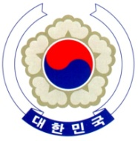

PERMANENT MISSION OF THE REPUBLIC OF KOREA
GENEVA

The 37th Session of the UPR Working Group <Check against delivery>
Review of Australia
Geneva, 20 January 2021

Statement of the Republic of Korea

Thank you, Madam President,

The Republic of Korea commends Australia’s continued efforts to implement the recommendations of its last review. We especially welcome the ratification of the OPCAT and the launch of new National Agreement on Closing the Gap which has been developed in partnership with indigenous representative bodies.

Bearing this in mind, we would like to recommend Australia to:

- Continue to work toward narrowing the gap in life outcomes between indigenous and non-indigenous Australians, with a special focus on better access to health, education, and employment opportunities;

- Prioritize violence prevention strategies when developing the next National Plan to Reduce Violence against Women and their Children; and

- Take concrete steps to improve its treatment of asylum seekers, refugees, and migrants, including reducing the detention period and improving detention conditions.

We wish Australia a successful review. I thank you.
/END/

Optional Protocol to the Convention against Torture and other Cruel, Inhuman or Degrading Treatment or Punishment

