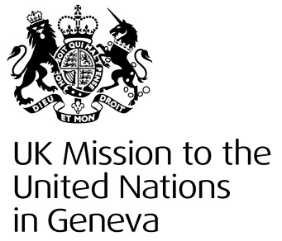

United Kingdom of Great Britain & Northern Ireland
Statement

37th Universal Periodic Review – Austria
22 January 2021

The United Kingdom commends Austria’s continued efforts to eliminate discrimination on the grounds of sexual orientation and the steps it has taken since its last UPR to improve equality for same-sex partnerships, including legally recognising same-sex marriage.
The UK welcomes Austria’s positive action in promoting media freedom internationally. We encourage Austria to take further steps to combat all forms of discrimination, including racial bias within law enforcement.
We recommend that Austria:
- Operationalise domestically the insights arising from its October conference on ‘Human Trafficking in Times of Corona’.

- Prioritise developing a strategy against racism, xenophobia, radicalisation and violent extremism, taking into account the views of civil society and underpinned by necessary legislation and budgetary resource.

- Adopt an open, merit-based process when selecting national candidates for UN Treaty Body elections.

Thank you.

