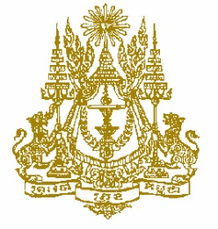
STATEMENT BY CAMBODIA
At the consideration for adoption of the UPR Report of Austria
37th Session of the UPR Working Group
22 January 2021
86

Madame President,
- Cambodia welcomes the Austria’s engagement in the UPR process and wishes to offer three recommendations as follows:
- First, consider taking additional steps to increase its ODA contribution to reach 0.7% of GNI.
- Second, take further measures to strengthen economic and social inclusion of victims of trafficking through provision of vocational training, language course and job placement.
- Third, intensify further efforts to address extremist and discriminatory attitudes and behaviors through preventive and repressive measures.
- Finally, I wish the delegation of Austria every success in this review.
I thank you, Madame President!

----------

