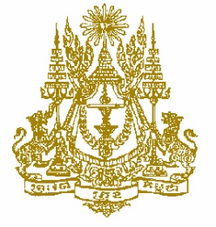
STATEMENT BY CAMBODIA
At the consideration for adoption of the UPR Report of Lebanon
37th Session of the UPR Working Group
18 January 2021

Madame President!
- Cambodia recognizes Lebanon’s concrete endeavors to fulfill obligations under charter-based and treaty-based mechanisms, and its cooperation with the special procedure mandate holders.
- My delegation welcomes Lebanon’s passing of many legislations in conformity with the previous cycle recommendations.
- Madame President, we commend Lebanon’s initiative to replace certain penalties, with unpaid social work, which contribute to addressing the prison overcrowding.
- In the constructive spirit, we would like to suggest two recommendations for Lebanon:
- First, consider intensifying further efforts to safeguard, protect and rehabilitate child victims of human trafficking and those at risk of being trafficked.
- Second, consider taking additional steps to increase capacity building trainings for detention-center officials.
- Finally, I wish the delegation of Lebanon every success in this review.
I thank you, Madame President!

