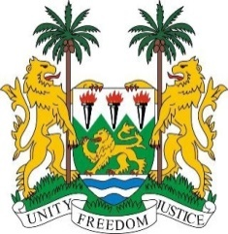
SIERRA LEONE
37th Session of the UPR (18-29 January 2021)

UPR Review of Austria

22 January 2021

Madam President,
Sierra Leone warmly welcomes the delegation of Austria to the UPR. We thank the delegation for their comprehensive report and presentation today.

We commend Austria for expanding support for victims of human trafficking, for raising the marriage age to 18 and for ratifying the Protocol of 2014 to the Forced Labour Convention, 1930. Sierra Leone also commends Austria’s efforts in addressing hate speech.
We also note the adoption of seventh National Reform Programme in 2017 and the goal of Austria to increase the employment rate among women and men aged between 20 and 64.
In the spirit of constructive engagement Sierra Leone would like to recommend the following to Austria:
- Establish an independent national human rights institution in conformity with the Paris Principles
- Strengthen its efforts to combat acts or advocacy of racial or religious hatred, by adopting a national action plan against racism;
- Decriminalize defamation under the Criminal Act in accordance with international best practice;
- Reinstate humanitarian admission programme

Sierra Leone wishes the delegation of Austria a successful review.

I thank you, Madam President

