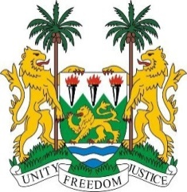
SIERRA LEONE
37th Session of the UPR (18th – 29th January 2021)

UPR Review of Lebanon

18 January 2021

Madam President,
Sierra Leone thanks the delegation of Lebanon for the presentation of its national report and for its engagement with the UPR process.
Sierra Leone mourns the devastation of the Beirut port explosion last year, and we share our grief with the government and people of Lebanon.
We note with appreciation the establishment of its National Human Rights Commission including the Committee for the Prevention of Torture. We also note Lebanon’s cooperation with the human rights mechanism with specific reference to the submission of its periodic reports to treaty bodies and for welcoming special procedure mandate holders.
In the spirit of constructive engagement, Sierra Leone recommends that Lebanon:

- Abolish the kafala system and include domestic workers in their labour laws.
- Amend the nationality law to allow women to transfer their nationality to their children.
- Increase financial support to families in situations of poverty, with a view to reducing the institutionalization of children; and
- Strengthen the implementation of the national plan of action to prevent and address the involvement of children in armed violence.

Sierra Leone wishes Lebanon success with the implementation of the recommendations it receives during its third UPR cycle.
I thank you, Madam President

