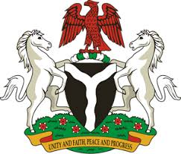
Please check against delivery
HUMAN RIGHTS COUNCIL
37TH SESSION OF THE WORKING GROUP OF THE UPR
REVIEW OF SAO TOME AND PRINCIPE
27TH JANUARY, 2021
STATEMENT BY NIGERIA
Madam Vice President,
Nigeria warmly welcomes the delegation of the Democratic Republic of Sao Tome and Principe to the presentation of the country’s National Report for the Third Cycle UPR. We take positive note of efforts by the Government of Sao Tome and Principe towards the implementation of previous recommendations, as well as its cooperation with the UPR mechanism.
2. Nigeria takes positive note of the Government’s efforts in the promotion and protection of human rights and fundamental freedoms. The Government’s efforts in ensuring the socio-economic wellbeing of its population are also noteworthy. We also commend Sao Tome and Principe for measures being adopted, with a view to protecting the rights of persons in vulnerable situations.
3. While acknowledging efforts by Sao Tome and Principe in upholding human rights and recognising the need for improvement, and in the spirit of constructive engagement, Nigeria recommends the following to Sao Tome and Principe:
- Adopt further measures to ensure poverty reduction and the empowerment of women, as well as the protection of the rights of persons in vulnerable situations;
- Scale up efforts in upholding human rights and seek necessary support to enhance its capacity in this regard.
4. In conclusion, we wish Sao Tome and Principe every success in its review process.
I thank you.
******

