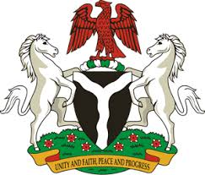
Please check against delivery
HUMAN RIGHTS COUNCIL
37TH SESSION OF THE WORKING GROUP OF THE UPR
REVIEW OF RWANDA
25TH JANUARY, 2021
STATEMENT BY NIGERIA
Madam Vice President,
Nigeria warmly welcomes the delegation of the Republic of Rwanda to the presentation of the country’s National Report for the Third Cycle UPR. We commend the Government of Rwanda for its efforts towards the implementation of previous recommendations, as well as its commitment to the UPR process.
2. Nigeria notes with encouragement Rwanda’s efforts at strengthening its legal and institutional frameworks for the promotion and protection of human rights. We applaud the Government of Rwanda for its determination to combat human trafficking, and efforts to ensure women empowerment.
3. While acknowledging efforts by Rwanda in upholding human rights and in the spirit of constructive engagement, Nigeria recommends the following to Rwanda:
- Continue efforts in ensuring access to justice, and the fight against corruption; and
- Sustain efforts in ensuring the enjoyment of human rights by all, especially persons in vulnerable situations.
4. In conclusion, we wish Rwanda every success in its review process.
I thank you.
******

