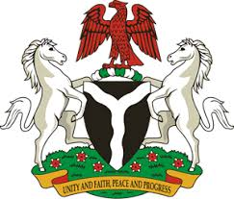
Please check against delivery
HUMAN RIGHTS COUNCIL
37TH SESSION OF THE WORKING GROUP OF THE UPR
REVIEW OF NEPAL
21ST JANUARY, 2021
STATEMENT BY NIGERIA
Madam Vice President,
Nigeria welcomes the delegation of the Federal Democratic Republic of Nepal to the presentation of the country’s Third Cycle UPR National Report. We commend the Government of Nepal for its cooperation and commitment to the UPR process, and its efforts in implementing previous recommendations.
2. We laud the Government of Nepal for its efforts in combatting human trafficking, gender-based violence, and the protection of the rights of migrants, as well as victims of human trafficking. We take positive note of the Government efforts in ensuring economic, social and cultural rights, especially measures being adopted with a view to ensure poverty reduction.
3. In the spirit of constructive engagement, Nigeria recommends the following to Nepal:
- Scale up efforts in combatting human trafficking, and protecting the rights of victims, as well as the rights of migrants; and
- Continue efforts in ensuring access to justice, poverty reduction, and the protection of the rights of persons in vulnerable situations.
4. In conclusion, we wish Nepal a very successful review process.
I thank you.
******

