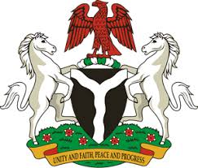
Please check against delivery
HUMAN RIGHTS COUNCIL
37TH SESSION OF THE WORKING GROUP OF THE UPR
REVIEW OF MAURITANIA
19TH JANUARY, 2021
STATEMENT BY NIGERIA
Madam Vice President,
Nigeria warmly welcomes the delegation of the Islamic Republic of Mauritania to the presentation of the country’s Third Cycle UPR National Report. We commend the Government of Mauritania for its commitment to the UPR process, and its efforts in implementing recommendations it accepted during the previous review.
2. Nigeria notes with commendation, the Government’s efforts in strengthening the country’s legal and institutional frameworks for the promotion and protection of human rights. We also take positive note of measures adopted in the fight against human trafficking, and the protection of persons in vulnerable situations.
3. In the spirit of constructive dialogue, Nigeria recommends the following to Mauritania:
- Scale up efforts in combatting human trafficking, and protecting the rights of victims, as well as the rights of migrants and persons in vulnerable situations; and
- Continue to mobilise resources and seek necessary support to enhance its capacity to protect and promote human rights.
4. To conclude, we wish Mauritania a very successful review process.
I thank you.
******

