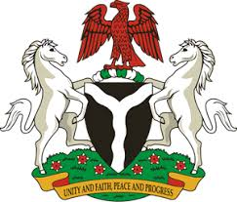
Please check against delivery
HUMAN RIGHTS COUNCIL
37TH SESSION OF THE WORKING GROUP OF THE UPR
REVIEW OF LEBANON
18TH JANUARY, 2021
STATEMENT BY NIGERIA
Madam President,
Nigeria welcomes the delegation of the Lebanese Republic and thanks it for the presentation of the country’s Third Cycle UPR National Report. We commend the Government of Lebanon for its efforts in implementing the previous recommendations, and its continued cooperation and engagement with the UPR process.
2. Nigeria takes positive note of Lebanon’s effort in combatting human trafficking, and ensuring the protection of the rights of migrant workers. The Government efforts in fighting corruption and the protection of persons in vulnerable situations are also commendable.
3. While acknowledging the various efforts by the Government in the field of human rights, and in the spirit of constructive engagement, Nigeria makes the following recommendations to Lebanon:
- Adopt further measures in combatting human trafficking, and ensure the protection of the rights of victims, as well as the rights of migrant workers;
- Scale up efforts in the fight against corruption and poverty.
4. In conclusion, we wish Lebanon a very successful review process.
I thank you.
******

