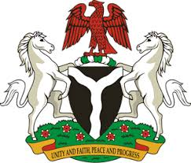
Please check against delivery
HUMAN RIGHTS COUNCIL
37TH SESSION OF THE WORKING GROUP OF THE UPR
REVIEW OF GEORGIA
26TH JANUARY, 2021
STATEMENT BY NIGERIA
Madam President,
Nigeria welcomes the delegation of Georgia and thanks it for the presentation of the country’s National Report for the Third Cycle UPR. We commend the Government of Georgia for its continued cooperation and engagement with the UPR process.
2. Nigeria takes positive note of the Government’s efforts to combat violence against women, including domestic violence, hate and discrimination. We also note with encouragement measure being adopted by Georgia in combatting human trafficking and protecting the rights of victim, as well as the rights of migrants.
3. In the spirit of constructive engagement, Nigeria makes the following recommendations to Georgia:
- Adopt further measures in combatting human trafficking, and ensure the protection of the rights of victims, as well as the rights of migrants; and
- Continue efforts in ensuring the full enjoyment of human rights by all its population without discrimination.
4. Finally, we wish Georgia a very successful review process.
I thank you.
******

