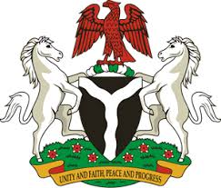
Please check against delivery
HUMAN RIGHTS COUNCIL
37TH SESSION OF THE WORKING GROUP OF THE UPR
REVIEW OF AUSTRIA
22ND JANUARY, 2021

STATEMENT BY NIGERIA
Mr. Vice President,
Nigeria welcomes the delegation of Austria to the presentation of the country’s National Report for the Third Cycle UPR, and thanks it for the update provided today. We commend the Government of Austria for its cooperation and commitment to the UPR process.
2. Nigeria applauds the Government of Austria for its efforts in combatting human trafficking, and protecting the rights of victims, as well as the rights of migrants. We take positive note of Austria’s efforts in fighting racism, hate speech and hate crimes.
3. In the spirit of constructive dialogue, Nigeria makes the following recommendations to Austria:
- Scale up efforts in combatting racism, racial discrimination and hate crimes; and
- Adopt further measures in combatting human trafficking, and protecting the rights of victims, as well as the rights of migrants.
4. In conclusion, we wish Austria a very successful review process.
I thank you.
******

