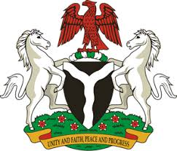

Please check against delivery
HUMAN RIGHTS COUNCIL
37TH SESSION OF THE WORKING GROUP OF THE UPR
REVIEW OF AUSTRALIA
20TH JANUARY, 2021
STATEMENT BY NIGERIA
Madam President,
Nigeria welcomes the delegation of Australia, and thanks it for the presentation of the country’s Third Cycle UPR National Report. We commend the Government of Australia for its continued cooperation and commitment to the UPR process and other human rights mechanism.
2. In the spirit of constructive engagement, Nigeria recommends the following for the consideration of Australia:
- Strengthen measures to ensure the full enjoyment of human rights by all its population without discrimination; and
- Sustain efforts in combatting human trafficking and ensuring the protection of the rights of victims, as well as the rights of migrants.
3. In conclusion, we wish Australia every success in its review process.
I thank you.
******

