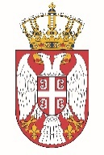

Permanent Mission of the Republic of Serbia to the United Nations Office in Geneva

Working Group for UPR
Interactive Dialogue on Report of Sao Tome and Principe
January 2021

The Republic of Serbia welcomes the participation of Sao Tome and Principe within the UPR process, and thanks for the presentation of its national report.
Serbia appreciates all the efforts invested by Sao Tome and Principe while implementing recommendations from the previous cycle.
Serbia in particular welcomes the measures taken aimed at strengthening the capacity of judicial system.
We would like to recommend to Sao Tome and Principe to step up efforts to provide drinking water and sanitation in all parts of the country.

We wish Sao Tome and Principe a successful review.

