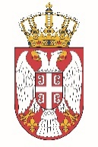

Permanent Mission of the Republic of Serbia to the United Nations Office in Geneva

Working Group for UPR
Interactive Dialogue on Report of Myanmar
January 2021

The Republic of Serbia welcomes the participation of Myanmar within the UPR process, including this interactive dialogue.
Serbia acknowledged all the efforts invested by the authorities of Myanmar while implementing recommendations from the previous cycle.
Serbia in particular welcomes those measures aimed at facilitating public access to court services.
We would like to recommend to Myanmar to intensify cooperation with all UN bodies in the field of human rights protection, including the UN Special Rapporteur on Myanmar, for the benefit of all people living in Myanmar, especially with regard to the situation of women and children.

We wish Myanmar a successful review.

