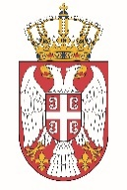

Permanent Mission of the Republic of Serbia to the United Nations Office in Geneva

Working Group for UPR
Interactive Dialogue on Report of Georgia
January 2021

The Republic of Serbia warmly welcomes the participation of Georgia within the UPR process, and thanks for the presentation of its national report.
Serbia appreciates all the efforts invested by the authorities of Georgia while implementing recommendations from the previous cycle.
Serbia in particular welcomes the measures taken aimed at fighting hate crimes.
We would like to recommend to Georgia to strive to allocate all the necessary human, technical and financial resources to the institutions in charge of monitoring the implementation of the Law on the Elimination of all Forms of Discrimination, especially for the Office of the Public Attorney.

We wish Georgia a successful review.

