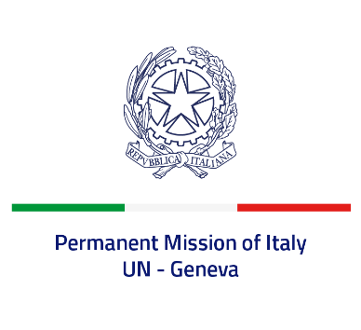
Check against delivery
UPR 37 - Oman
Thursday 21 January 2021, 14:30 - 18:00

Delivered by: Minister Marie Sol Fulci, Deputy Permanent Representative of Italy

(Focal point: Angela Zanca, First Secretary)

Thank you, Madam President.

We thank the delegation of Oman for their presentation and their commitment to the UPR.

Italy commends the ratification of the Convention against Torture, the Covenant on Economic, Social and Cultural Rights, and the Convention for the Protection of All Persons from Enforced Disappearance. We also appreciate Omani efforts against human trafficking.

Italy wishes to offer Oman the following recommendations:

- Strengthen the efforts to eliminate female genital mutilation by increasing public awareness of the harmful consequences of its practice.
- Withdraw reservations to the Convention on the Elimination of All Forms of Discrimination against Women and review current provisions that are discriminatory against women, including rights in marriage, divorce, inheritance, and in transmitting nationality onto their children and spouses.
- Establish a moratorium on executions with a view to abolishing the death penalty.
- Recognize the right to peacefully exercise freedom of expression, association and assembly and remove or revise legal provisions criminalizing those rights.
- Revise the kafala system to reduce the risk of migrant workers being subject to labor exploitation.

We wish Oman a successful review.
I thank you.

