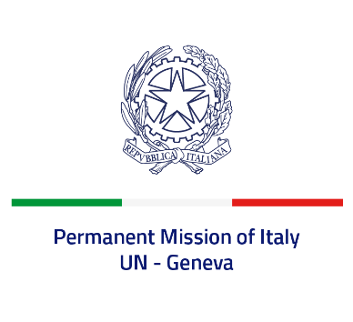
Check against delivery
UPR 37 – Nepal
Thursday 21 January 2021, 9:00 – 12:30

Delivered by: Ambassador Gian Lorenzo Cornado, Permanent Representative of Italy

(Focal point: Daniele Borrelli, Counsellor)
Thank you, Madam President.

We thank the members of the delegation of Nepal for their national report and today’s presentation.

Italy commends the ratification of the Palermo protocol against human trafficking. We welcome the adoption of a National Child Labour Abolition Master Plan and of a National Strategy to end child marriage.

Italy seizes this opportunity to offer Nepal the following recommendations:
- Strengthen the enforcement of existing legislation and policies to eradicate the practice of child labor, in particular regarding hazardous work.
- Prevent and combat all forms of violence against women and girls, including child, early and forced marriage and other harmful practices, and take further measures to fight domestic violence.
- Continue the efforts to combat caste-based discrimination and segregation.
- Take appropriate measures to effectively address the cases related to violations of human rights and international humanitarian law that had occurred during the conflict period and provide justice to the victims.
We wish Nepal a successful review.
I thank you.

