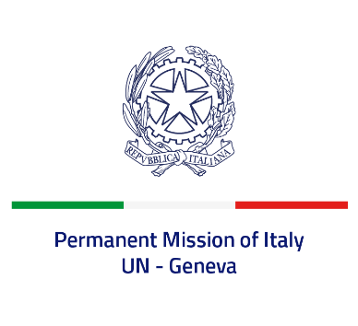
Check against delivery
UPR 37 - Federated States of Micronesia
Monday 18 January 2021, 9:00 – 12:30
Delivered by: Ambassador Gian Lorenzo Cornado, Permanent Representative of Italy

(Focal point: Daniele Borrelli, Counsellor)

Thank you, Madam President.

We thank the distinguished members of the delegation of the Federated States of Micronesia for their national report and today’s presentation.

Italy commends the accession to the Convention on the Rights of Persons with Disabilities. We welcome the launching of the first National Gender Policy and the development of the national Elimination of Violence Against Women policy. We also welcome the establishment of a new Division of Anti-Human Trafficking within the National Department of Justice, tasked with assisting in human trafficking investigations, training officials, raising public awareness and providing services for victims.

Madam President,
Italy seizes this opportunity to offer the Federated States of Micronesia the following recommendations:

- Accede to the main international conventions on human rights protection, starting from the International Covenant on Civil and Political Rights and the International Covenant on Economic, Social and Cultural Rights.
- Strengthen the efforts to prevent and combat any form of sexual and gender-based violence or discrimination against women and girls, including by adopting a federal legislation criminalizing violence against women.
- Continue the efforts to contrast human trafficking, in particular involving sexual exploitation and forced labor, including by enhancing the ability of the judicial system to investigate and prosecute the perpetrators and assisting the victims.

We wish the Federated States of Micronesia a successful review.
I thank you.

