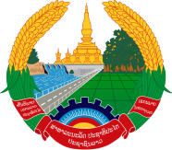
Statement by Representative of the Lao PDR
At the 37th Session of UPR Working Group
Geneva, 18-29 January 2021

Review of Nepal: 21 January 2021

Madam President,
Laos warmly welcomes the distinguished delegation of Nepal to the UPR session and thanks for the presentation of its National Report on human rights.

Laos congratulates Nepal for achievements made in the promotion and protection of human rights in the country through the implementation of its National Human Rights Action Plan.

We also commend the efforts of Nepal's government to improve the living standard of its people by significantly increasing investment in poverty reduction, health care, education and others.

In constructive spirit, Laos wishes to offer the following recommendations:

- Continue its efforts in poverty reduction by providing the poor families opportunities in accessing to productive resources, capacity building, income and sustainable development; and
- Further enhance the empowerment of women, through education, awareness, training for skill development and employment.

We wish Nepal a great success in its review.

I thank you, Madam President.

