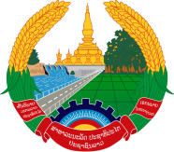
Statement by the Representative of the Lao PDR
At the 37th Session of UPR Working Group
Geneva, 18-29 January 2021

Review of Lebanon: 18 January 2021

Madam President,
Laos warmly welcomes the distinguished delegation of Lebanon to the UPR session and thanks for its comprehensive report presented today.

Laos would like to commend the progress made by the Lebanese’s Government in implementing the adopted recommendations from the previous UPR cycle as well as its commitment to further promote and protect human rights in the country, including through its National Programme to Support the Poorest Families in the fight against poverty.

In constructive spirit, Laos wishes to recommend as follows:

- Continuing its efforts in realizing the National Programme to Support the Poorest Families so as to alleviate and eradicate poverty in the country; and

- Strengthening its health care services, including through cooperation with international organisations, to ensure access to good quality health-care services especially during the COVID-19 pandemic for all persons, including persons without insurance.

We wish Lebanon every success in the review.

I thank you, Madam President.

