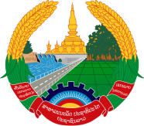
Statement by the Representative of the Lao PDR
At the 37th Session of UPR Working Group
Geneva, 18-29 January 2021

Review of Georgia: 26 January 2021

Madam President,
Laos welcomes the distinguished delegation of Georgia to the UPR session and thanks for its comprehensive report presented today.

Laos takes note of the efforts of the Government of Georgia in implementing the adopted recommendations from the previous UPR cycle as well as its commitment to further promote and protect human rights in the country, including through national measures and policies in safeguarding the rights of child, women and persons with disabilities.

In this connection, Laos wishes to offer the following recommendations:

- Continue its efforts to eliminate inequality of men and women in both public and private sectors, especially women in rural areas; and

- Further enhance its educational, healthcare and social security programmes to ensure that they are equally accessible for all.

We wish Georgia every success in the review.

I thank you, Madam President.

