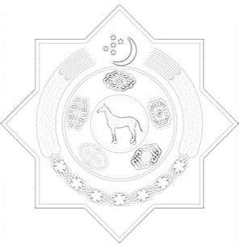
Statement by Turkmenistan
at the 37th session of the Working Group of Universal Periodic Review
UPR Review of the Sultanate of Oman

18-29 January 2021

Thank you, Madame President,

Turkmenistan extends its warm welcome to the distinguished delegation of the Sultanate of Oman to the UPR Working Group session and thanks it for the all-inclusive update on the implementation of previous UPR Cycle Recommendations.

We took note with appreciation all measures had been taken by the Government of Oman, including issuance of relevant decrees and establishment new institutions in order to protect and promote of human rights in the State,

Furthermore, welcoming the strengthened cooperation of the National institutions for protection of human rights with international human rights mechanisms and institutions,

Turkmenistan recommends:

- to continue its ongoing efforts to promote and strengthen human rights, in particular by focusing on the economic growth and by improving the well-being of the population

- to further strengthen the practices of valuing social dialogue and promoting the concept of tolerance in Omani culture;

- to pursue its efforts to enhance the working conditions of expatriate labourers by issuing legislation and regulations to promote and protect the rights of expatriate workers in Oman Labour Law.

In conclusion, Turkmenistan wishes the Government of Oman a successful implementation of UPR recommendations of the 3rd cycle.

I thank you.

Geneva, “21” January 2021

