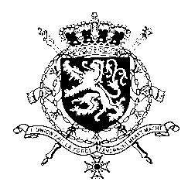
Représentation permanente de la Belgique auprès des Nations Unies et auprès des institutions spécialisées à Genève

WG UPR – Nepal
Belgian intervention
21 January 2021

Mr./Madam President,

Belgium congratulates the government of Nepal for adopting legislation abolishing and criminalising harmful practices and welcomes its pledge to address human rights violations during the conflict period through transitional justice mechanisms.

Nevertheless, Belgium is convinced more progress can be achieved, and recommends Nepal to:

R1. Bring the 2014 Act on the Commission on Investigation of Enforced Disappeared Persons, Truth and Reconciliation into compliance with international norms, particularly with regard to the definition of amnesty, witness protection and the delays in processing complaints;

R2. Ensure the effective implementation of the criminalisation of chhaupadi and wedding dowries, including by raising awareness amongst all stakeholders, imposing sanctions and prosecuting perpetrators;

R3. Ensure that child labour in the informal sector is incorporated into the Child Labour Act.
Thank you, Mr./Madam President.

