ቀዋሚ ሚሽን ሃገረ ኤርትራ ናብ ውድብ ሕቡራት ሃገራት  ጀኔቫ | 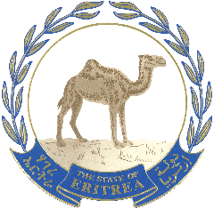 | البعثة الدائمة لدولة إريتريا  لدى الأمم المتحدة  جنيف
Permanent Mission of the State of Eritrea to the United Nations
GENEVA

37th Session of UPR Working Group,
Statement of the State of Eritrea _ Sultanate of Oman
21 January 2021

Madame Vice President,
Eritrea warmly welcomes the delegation of Oman and congratulates them for presenting their national report at this challenging time.
We commend positive developments in the areas of gender equality, rights of the child and the wider efforts to provide basic social services. We welcome efforts underway to combat human trafficking and discrimination of all types.
The establishment of different committees to improve health, education, and social security sectors are key to development and the enjoyment of human rights and fundamental freedoms.
Eritrea further appreciates the withdrawal of certain reservations mentioned in paragraph 11 of the National Report.
In a constructive spirit, Eritrea recommends the following:
- Step up efforts to promote equal rights to different social groups.
- Take further measures to guarantee foreign nationals a choice of their job and employer through the no objection condition introduced recently.
My delegation wishes Oman a successful review.
Thank you Madame Vice President

