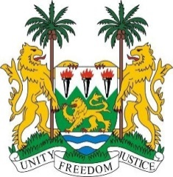
SIERRA LEONE
37th Session of the UPR

UPR Review of Myanmar
25 January 2021

Madam President,
Sierra Leone thanks the delegation of Myanmar for the presentation of its national report and for its engagement with the UPR process.
We would like to congratulate Myanmar for establishing a Human Rights Commission, as we recommend in the last UPR cycle. We note with appreciation the ratification of international treaties by Myanmar, notably, International Covenant on Economic, Social and Cultural Rights (ICESCR) and the Optional Protocol to the Convention on the Rights of the Child on the involvement of children in armed conflict (CRC-AC).
Despite these progress, Sierra Leone is deeply concerned about the deteriorating human rights situation in Myanmar including refusing access into the country to international observers. There are alarming reports regarding the treatment of religious minorities, and these attacks have no place in the modern world. Sierra Leone is committed to assisting in the international response to this situation.
In a constructive spirit, Sierra Leone recommend the following to Myanmar:
- Give unfettered and unconditional access to Special Procedure Mandate Holders.
- Abolish anti-discrimination law to prevent advocacy of national, racial, or religious hatred that constitutes incitement to discrimination and violence, in accordance with the Rabat Plan of Action;
- Adopt a comprehensive definition of discrimination against women in its national legislation, in line with the Convention on the Elimination of All Forms of Discrimination against Women; and
- Consider to conduct citizenship verification programme in a non-arbitrary and non-discriminatory basis, and grant the Rohingya national citizenship documents within a reasonable period.
- Ratify ICCPR, CAT, ICERD and ICRMW
- Adopt an official moratorium on the death penalty
Sierra Leone wishes Myanmar success with the implementation of the recommendations it receives during this third UPR cycle.
I thank you, Madam President

