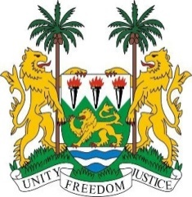
SIERRA LEONE
37th Session of the UPR (18-29 January 2021)

UPR Review of Rwanda
25 January 2021 (14:30 – 18:00)

Madam President,
Sierra Leone thanks the delegation of Rwanda for the presentation of its national report and for its engagement with the UPR process.
We note with appreciation the adoption and subsequent implementation of its first National Human Rights Action Plan. We also note the extension of the mandate of National Commission for Human Rights (NCHR), to cover the mandate of National Preventive Mechanisms (NPM) to ensure protection against torture, and other Cruel, Inhuman or Degrading Treatment or Punishment.
Sierra Leone recognizes the considerable progress that Rwanda has made, especially in empowering women in decision-making positions. We would also like to commend Rwanda for their policies to expand children education. There are many aspects of Rwanda’s journey that we aspire to emulate.
However, Sierra Leone is concerned about gender stereotypes and inadequate laws in addressing trafficking in persons.
In the spirit of constructive engagement Sierra Leone recommend for the consideration of Rwanda:
- Consider to investigate all allegations of extrajudicial, arbitrary or summary executions and enforced disappearances.
- Take steps to ensure the selection and appointment of members of the National Commission for Human are transparent and in compliance with the Paris Principles;
- Take concrete steps to ensure media independence.
- Enhance its efforts to combat all forms of gender-based violence against women, including domestic and sexual violence.
- Accelerate the adoption of the bill on trafficking in persons and child labour.
Sierra Leone wishes Rwanda success with the implementation of the recommendations it receives during this third UPR cycle.
I thank you, Madam President

