[Check against delivery]

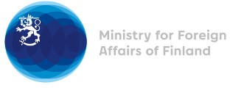

37 Session of the UPR working group Recommendations by Finland to Nepal

21 January 2021

Madame President,

Finland welcomes Nepal’s engagement in the UPR process and wishes to make the following recommendations:
- firstly, to take all necessary measures to ensure full inclusion and improved learning results for all children belonging to Dalits, underrepresented castes and indigenous peoples, including children with disabilities, at all levels of education, and to ensure the representativeness of these groups, especially women, in teaching positions;
- secondly, to adopt legislation that prohibits all forms of violence against women and girls to ensure that all cases are investigated and perpetrators brought to justice and that victims receive compensation as well as to strengthen awareness-raising programmes on harmful practices related to women and girls, like chhaupadi, child marriage, dowry, son preference, polygamy, and witchcraft; and
- thirdly, to ensure that the rights to acquire, transfer and retain citizenship are extended equally to all women and their children.

Thank you.

