[check against delivery]

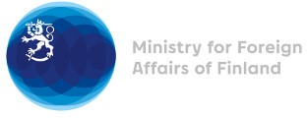

37 Session of the UPR Working Group Recommendations by Finland to Myanmar

25 January 2021

Madame President,

Finland appreciates the engagement of Myanmar in the UPR process and would like to recommend the following:

- firstly, to increase its efforts to implement the National Strategic Plan for the Advancement of Women 2013–2022, by ensuring the rights of women and girls and by protecting them from gender-based violence and discrimination as well as by allowing access of women and girls to information on sexual and reproductive health and rights;
- secondly, to review and amend all laws that violate the rights to freedom of expression, association and peaceful assembly as well as digital rights;
- thirdly, to include effective and meaningful participation and consultation of persons with disabilities in the implementation and monitoring of the Convention on the Rights of Persons with Disabilities.

Thank you.

