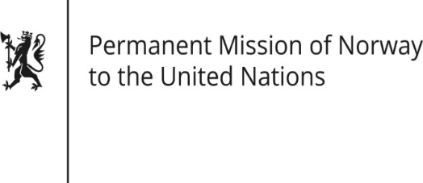

STATEMENT

Universal Periodic Review 37th session
Norway's statement during the 37th UPR session of the Human Rights Council on the human rights situation in Rwanda
as delivered by Ambassador Tine Mørch Smith,
Permanent Representative of Norway

25 January 2021

Check against delivery

Madam President,

Norway welcomes the progress Rwanda has made in terms of policies and legislation in areas such as freedom of expression, freedom of assembly and association, and protection of human rights defenders, but we remain concerned about the interpretation and actual implementation of legislation in these fields.

Norway recommends that Rwanda:
1) strengthens its progress on democratisation, the broadening of political and civil space, and the protection of human rights defenders;
2) takes measures to protect freedom of expression and protect journalists from harassment and injustices;
3) guarantees a vibrant civil society and the independence of NGOs by revising laws affecting their registration and operations;
4) allows independent investigations of allegations of torture and ill-treatment in detention facilities;
5) ensures the effective application of its legislation against gender based violence, and investigates, prosecutes and condemns perpetrators of sexual and gender based violence.

Thank you.

