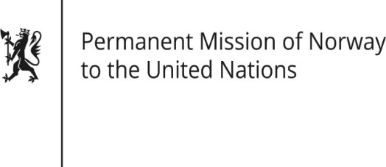

STATEMENT

Universal Periodic Review 37th session
Norway's statement during the 37th UPR session of the Human Rights Council on the human rights situation in Georgia
as delivered by Ambassador Tine Mørch Smith,
Permanent Representative of Norway

26 January 2021

Check against delivery

Madam President,

Norway welcomes the positive steps taken since the last review, including the establishment of the State Inspector’s Service.

Norway recommends that Georgia:

1. increases the efforts of political leaders to publicly acknowledge and protect the important role of human rights defenders and independent human rights institutions in the democratisation process;

2. adopts and implements without delay the recommendations from the Venice Commission related to reforms in the system for appointments of judges;

3. strengthens the State Inspector’s Service both institutionally and functionally to enable it to effectively investigate human rights abuses by all types of state employees;

4. ensures the right to just and fair conditions of work by strengthening the Labour Inspectorate to enable it to implement its expanded role under the recently amended Labour Code;

5. takes further measures to combat hate speech and violence against LGBTI-persons.

Thank you.

